INDUSTRIAL PRACTICES FINAL REPORT
Online Social Network Message Anonymization
at National Institute of Technology, Gifu College

Proposed for fulfilling the pass requirements of
IF4090 Industrial Practice Course

by :
Geraldi Dzakwan / 13514065



INFORMATICS ENGINEERING STUDY PROGRAM
SCHOOL OF ELECTRICAL ENGINEERING & INFORMATICS
BANDUNG INSTITUTE OF TECHNOLOGY
2017
Informatics Engineering Study Program Approval Sheet
Online Social Network Message Anonymization
at National Institute of Technology, Gifu College

by :
Geraldi Dzakwan / 13514065

approved and validated as
Industrial Practice Final Report

Bandung,
ITB Informatics Engineering Study Program Industrial Practice Supervisor

Dr. Eng. Ayu Purwarianti, S.T., M.T.
NIP: 19770127 200801 2 011
Approval Sheet
Online Social Network Message Anonymization
at National Institute of Technology, Gifu College

by :
Geraldi Dzakwan / 13514065

approved and validated as
Industrial Practice Final Report

Motosu, 19 July 2017
Electrical and Computer Engineering Department Professor

Prof. Makoto Yasuda
ID :
Abstract

This final report is for my industrial practice at National Institute of Technology, Gifu College. I did research about Online Social Network Message Anonymization. This type of anonymization is relatively new because it takes raw text (social media message) as the input instead of structured input like commonly found in k-anonymization techniques (e.g. for anonymizing medical record database). The research is done at Artificial Intelligence lab under the supervision of Prof. Makoto Yasuda.

The method used in the research mainly involve machine learning and natural language processing techniques. The first step is to do some preprocessings for the text (e.g. stemming) to clear unuseful information. Next step is to determine the named entities from raw text. I did some experiments using several classifiers (Naive Bayes, Perceptron, etc.) and using state of the art algorithm (Conditional Random Field). I ended up choosing CRF algorithm as it produces better result. Then, for each type of named entity there will be it’s own mechanism to determine whether it is a private phrase using steps like calculating co-occurence metrics with user profile and executing rule-based approach. Next, the detected private named entity will be anonymized in a specific way according to it’s type. Finally, there are some post processings to produce the final anonymized message.

The result of the program is good at detecting named entity, with the accuration above 80%. But, the private named entity detection still needs to be improved since there are many other cases/patterns to cover. Often in my program, there are cases when private phrases are not anonymized or vice versa (non-private phrases are anonymized). One of the solution that may works is to apply co-reference resolution to the private named entity detection step. It basically will determine all the words that refer to the same thing and that may improves the private named entity detection performance.

To sum up, I want to give two conclusions, one is about the research substance and the other one is about the industrial practice at National Institute of Technology, Gifu College (NIT-GC). There are currently not many anonymization research focusing on raw text. Thus, I hope that this research could be extended furthermore in the future in term of improving performance by applying other methods and also in term of domains/areas. I hope that I can also create similar researchs for other domains, such as for raw company or government documents. Overall, the industrial practice at NIT-GC is both challenging and fun. It’s challenging because the supervisor always gives you feedbacks and urges you to improve your work. Meanwhile, it’s fun because it’s Japan and all the students in the lab are very nice and helpful. They will invite you to play games and to eat at some delicious Japanese restaurants. They will also take you to some beautiful cities in Japan, such as Kyoto, Osaka, and Nagoya in the free time (weekend).

Keywords: online social network, text anonymization, social media message, classifier, conditional random field, private named entity, co-occurence metrics, rule-based approach, phrase generalization, preprocessing, postprocessing, machine learning, natural language processing

Preface

I would like to express my biggest thanks to my internship supervisor, Prof. Makoto Yasuda as he already gave me an opportunity to study in his lab and he also gave me guidances and feedbacks to improve my work results.

I would also like to give my deepest gratitudes to Dr. Eng. Yoshito Ito as the principal of NIT-GC who warmly welcomed me and JASSO which supported me financially to fulfill all my daily expenses while staying in Japan.

My thanks also go to my industrial practice supervisor at ITB, Dr. Eng. Ayu Purwarianti, S.T., M.T. as she always supported me since the preparation for the internship, including documents preparation for Japan visa and for JASSO scholarship.

I would also not forget to give my thanks to all NIT-GC staffs who helped me out in administrative processes (Prof. Koji Tajima, Mr. Michael Makoto Martinsen, and Mr. Isao Tomita) and to all my friends in the lab (Hideki Kano, Ryosuke Okachi, etc.) which I couldn’t mention all individually. Thank you for taking me around Japan and helping me to find the way out of problems I faced during the internship.

Motosu, 19 July 2017
Geraldi Dzakwan

Table of Contents
Informatics Engineering Study Program Approval Sheet i
Approval Sheet ii
Abstract iii
Preface iv
Table of Contents v
List of Terms and Abbreviations vi
List of Tables vi
List of Pictures vi
Chapter I Introduction I-1
I.1 Background I-1
I.2 Scope I-1
I.3 Goal I-1
Chapter II Industrial Practice Work Environment II-1
II.1 Organization Structure II-1
II.2 Project Scope II-1
II.3 Project Description II-1
II.4 Project Schedule II-1
Chapter III Online Social Network Message Anonymiation III-1
III.1 <Deskripsi persoalan sesuai dengan topik KP > III-1
III.2 <Beri judul sub Chapter sesuai dengan proses pelaksanaan KP> III-1
III.3 < Beri judul sub Chapter sesuai dengan pencapaian hasil dari KP > III-2
Chapter IV Closing IV-1
IV.1 Conclusion IV-1
IV.2 Suggestion IV-1
References viii
Attachment A. Term of References A-1
Attachment B. Log Activity B-1

List of Terms and Abbreviations

TBD.

List of Tables

TBD.

List of Pictures

TBD.

Pendahuluan

Chapter I

Introduction

This chapter contains introduction about the industrial practice, including background, scope, and goal.

Background
Generally, this internship program aims to develop basic research skill in some specific fields that depends on which laboratory the student will choose and what research topic the student will pick. In addition, this internship program is expected to be a bridge between the two countries, Indonesia and Japan, in order to maintain a good relation, especially between Bandung Institute of Technology (ITB) and NIT, Gifu College. This program is also expected to improve the students’ communication skill from both schools especially in English.

Regarding the research subject, the student will be given several research topics from each laboratory. For this term of internship, there are two laboratories which accept ITB students. They are Tajima laboratory and Yasuda laboratory. Then, the students need to choose their preferred laboratory and their preferred topic or they can also propose their own topic (if approved by the laboratory professor). Afterwards, the student will do research project based on the selected topic. The research project will be conducted for 5 to 6 weeks and it will be supervised by the laboratory professor directly. At the end of the internship program, the student shall submit his internship report to the internship supervisor in NIT, Gifu College. This part of document is referred from the Term of Reference (TOR) attachment chapter one (objectives).

Scope

Goal
The main goal of this research project is to create an anonymization program (API) for social media message which has good accuracy on determining named entities and on determining private phrases. In this context, private phrases all are phrases that may lead to or may identify a person’s identity and phrases that are containing user’s private information (such as location). Despite making the message anonymized, the message still has to be useful in some ways so it can be used for other purposes such as analytics by third parties. So, there are two parameters that should be satisfied by the result (the anonymized message). The result has to guarentee that it close all user’s private information that can lead to his/her identity but at the same time it has to do minimum number of replacement so the result is not far from the original message and the result remains useful.

For further implementation, this anonymization API can be used by messaging applications (such as LINE, WhatsApp, Telegram) to share their message data to third parties. Normally, in today’s practice, messaging applications need to strictly encrypt all the messages so the information can’t be stolen by third parties. But, actually there are many third parties who want to take benefits from social media messages for doing analytics. The analytics result can be used for supporting some business intelligence processes (e.g. for taking decision in digital marketing). Usually, third parties use public data such as user’s tweets to do analytics. But, with this anonymization API they can legally use social media messages (that are already anonymized) for the sake of their analytics. Perhaps this new dataset (social media messages) can bring improvements to their analytics. Meanwhile, messaging applications can also take benefit by monetizing the messages data (e.g. third parties are charged per request made). So, I think this research topic could lead to something good in the future.

Organisasi atau Lingkungan Kerja Praktek

Chapter II

Industrial Practice Work Environment

This chapter contains the details of the workplace (organization) and it’s work environment, including organization structure of Gifu National College of Technology, project scope, project description, and project schedule.

Organization Structure
Generally, NIT-GC organization structure is the same as other colleges organization structure. It consists of some administrative committees and seven departments. Below is the illustration of NIT-GC organization structure. The lab I am working at (AI Lab, Prof. Makoto Yasuda) is the part of Electrical and Computer Engineering department, highlighted by a red ellipse. Another lab belongs to this department is Computer Network Lab, under Prof. Koji Tajima.

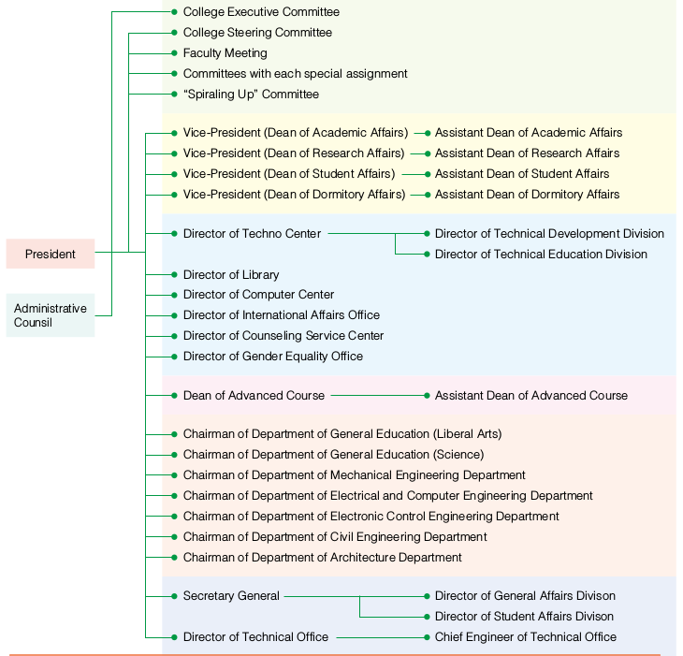

Picture II.1.1 NIT-GC Organization Structure

Project Scope
The research that will be conducted during the internship program is related to computer science field of study, especially natural language processing and machine learning. The research title is “Online Social Network Message Anonymization”. It will be held at Yasuda Laboratory and supervised by Prof. Makoto Yasuda. The student will carry out two projects, which are:

a. Training Named Entity Recognizer
In this project, the student should be able to make a program for predicting named entities from an input word/phrase. The program will use a trained model that will be built using Python Scikit-Learn module (a popular machine learning module in Python). The student will do several experiments using different classifier or algorithm and different data train sample. The student will then decide which model is to be used in the message anonymization API based on the accuracy testing. For the dataset which will be used in training, the student will use Groningen Meaning Bank corpus as so far it is the biggest, most complete, and most suitable English corpus the student has found.

b. Creating Message Anonymization Program (API)
This project is the next step after the first project. This project will use the model which has been created in the first project. The program will
probably be in the form of web API, built using either Flask or Django framework. This project will receive an input message (a private message, consisting of one or more sentences, using JSON format) from a client via HTTP POST request. Then, it will do some pre-processing procedures (e.g. sentence tokenizing, POS tagging, NP-chunking and punctuation removal). The result of preprocessing will be delivered to the classifier. The classifier then will return the sentences back to the program with identified named entities. Afterwards, the program will do some post- processing procedures (e.g. correction, co-reference resolution, and sentence restructuring). Last but most important procedure is to apply the
anonymization. There are two ways of doing the anonymization, the first one is to replace the named entities with their class (PERSON, LOCATION, ORGANIZATION, etc.) or to replace it with another phrase which belongs to the same class so it becomes more natural. The student will try to explore both options. The restructured sentences which have been anonymized then be sent back to the client via JSON message response.

This part of document is referred from the Term of Reference (TOR) attachment chapter two (project scopes).

Project Description
TBD.

Project Schedule
Generally, the student must come to the laboratory every work day (Monday- Friday), from 9.00 a.m. until 16.10 p.m. to work on the research project. Despite that, other activities might take place during research time, such as attending welcoming ceremony and welcoming party, weekly talk café (interacting with NIT-GC students) and giving presentation in some classes. The detailed schedule can be seen below. There are two pictures, the first one shows Gantt chart for the first project and the second one shows Gantt chart for the second project.

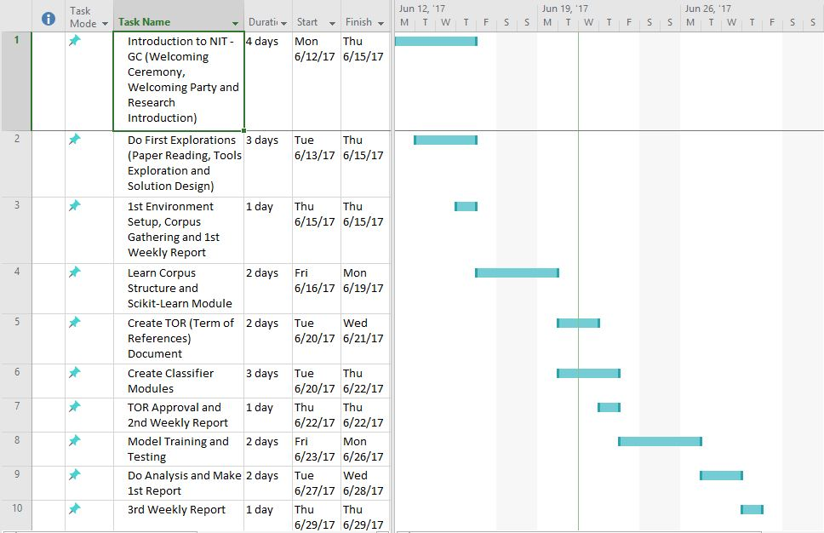
Picture II.4.1 Project 1 Gannt Chart



Picture II.4.2 Project 2 Gannt Chart

This part of document is referred from the Term of Reference (TOR) attachment chapter eight (schedule).

<Beri Judul sesuai dengan topik KP>

Chapter III

Online Social Network Message Anonymization

TBD.

Problem Description
TBD.

Solution Design and Implementation
TBD.

Result and Analysis
TBD.

Penutup

Chapter IV

Closing

This chapter contains two closing parts, which are the conclusion and suggestion. The conclusion is derived from the research project the student has completed and also from the work environment in NIT-GC. Meanwhile, the suggestion is about some future works and/or improvements that can be accomplished and the student’s feedback regarding the industrial practice.

Conclusion
1. Conclusion 1
2. Conclusion 2
3. Conclusion 3

Suggestion
1. Suggestion 1
2. Suggestion 2
3. Suggestion 3
References

TBD.

Attachment A. Term of References

Attachment B. Log Activity

